**Summary of Project: “Influence of Global Population, Fossil Fuel Consumption and GDP on CO2 Emissions”**

**Major findings:**

* Understanding and analyzing global carbon footprints by fossil fuel type by world region.
* At year 2015, coal makes up 45.2% of Total CO2 emissions from fossil fuels.
* China is the top emitter of CO2 emissions produced by coal total since 1971 (31.9%) and in year 2015 (51%).

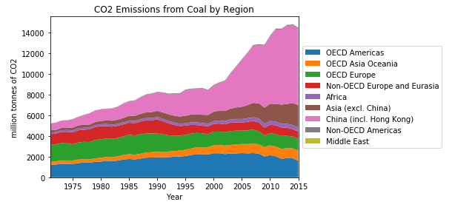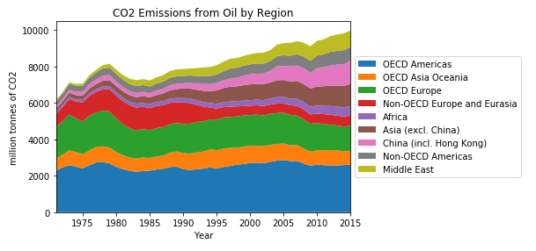

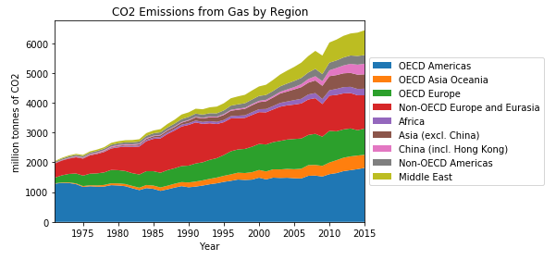

* What role does population and GDP have in CO2 emissions over time?
* Population and GDP have a positive correlation with CO2 emissions.
* 95.5% of the total variability in Y (CO2 emissions) is explained by its regression on X (Population).
* If global population grows based on this linear model, we will emit approximately 46,812 (MtCO2) in 2055 once we reach a population of 10 billion people per UN estimates.

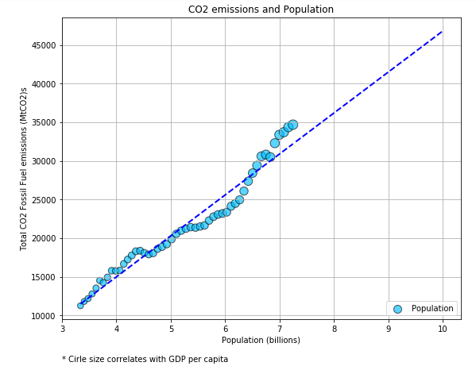

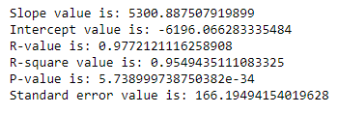

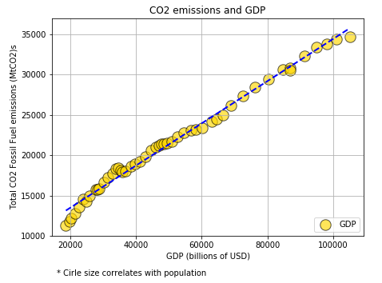

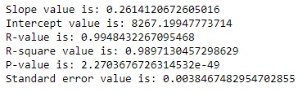

* How has the world energy demand contributed to global CO2 emissions?
* World energy consumption has a positive correlation with Global CO2 emissions.

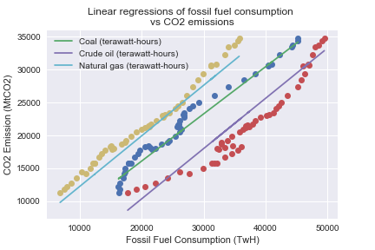

Coal Slope value is: 0.7159557159035506  
Coal Intercept value is: 2502.12593280504  
Coal R-value is: 0.9860780314166474  
Coal R-square value is: 0.972349884042306  
Coal P-value is: 4.6304870982307086e-39  
Coal Standard error value is: 0.017426201724543653  
-------------------------------------------------  
Oil Slope value is: 0.7626066781813275  
Oil Intercept value is: -6393.87773199279  
Oil R-value is: 0.9577155437463142  
Oil R-square value is: 0.9172190627332982  
Oil P-value is: 1.2804678831868618e-27  
Oil Standard error value is: 0.03306805253812809  
-----------------------------------------------------  
Gas Slope value is: 0.7672870431976115  
Gas Intercept value is: 5984.682281870968  
Gas R-value is: 0.99315923916755  
Gas R-square value is: 0.9863652743438668  
Gas P-value is: 1.9653163882239408e-46  
Gast Standard error value is: 0.013020916704700345

**Conclusions:**

* Based on our analysis, we can reject our Null hypotheses.
* The relationship between fossil fuel consumption, population and GDP with CO2 emissions is significant.
* We should reduce our global carbon footprint and move towards cleaner energies.